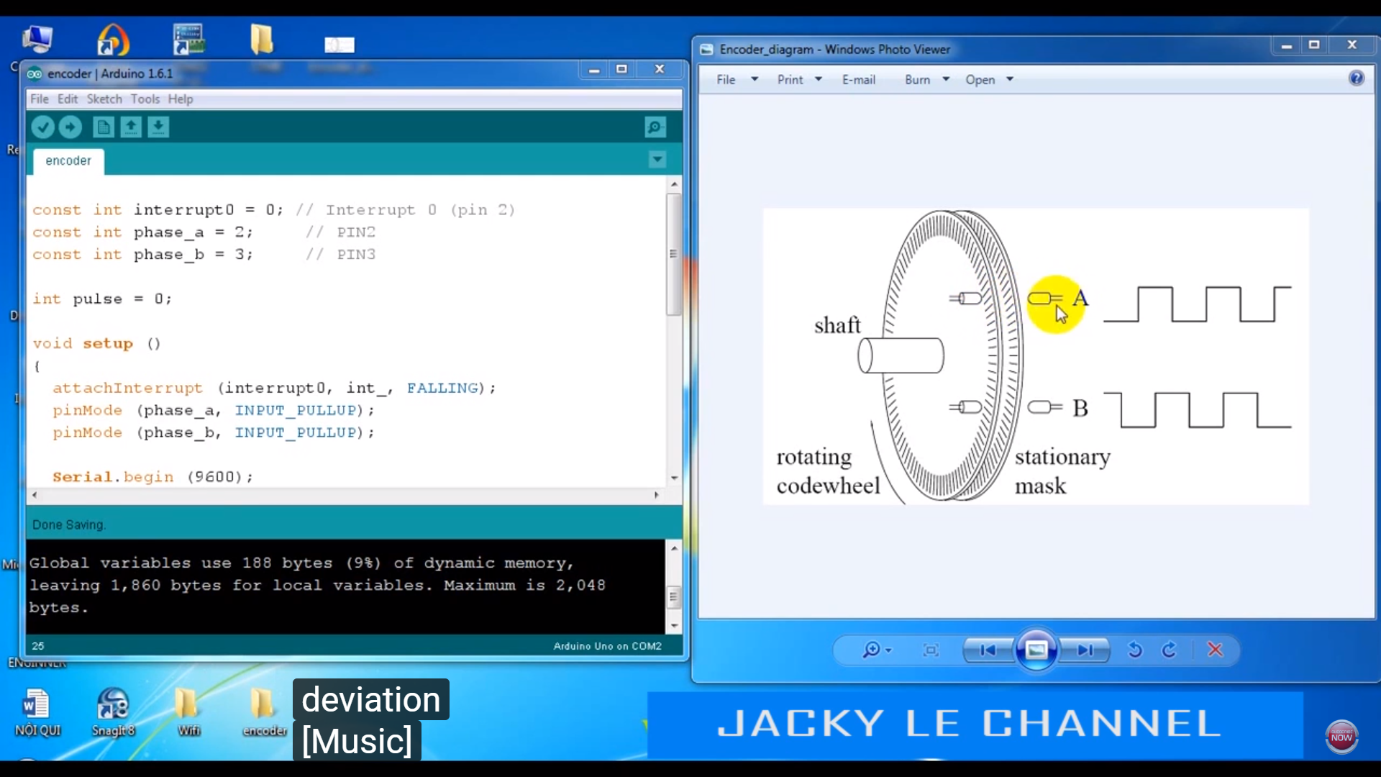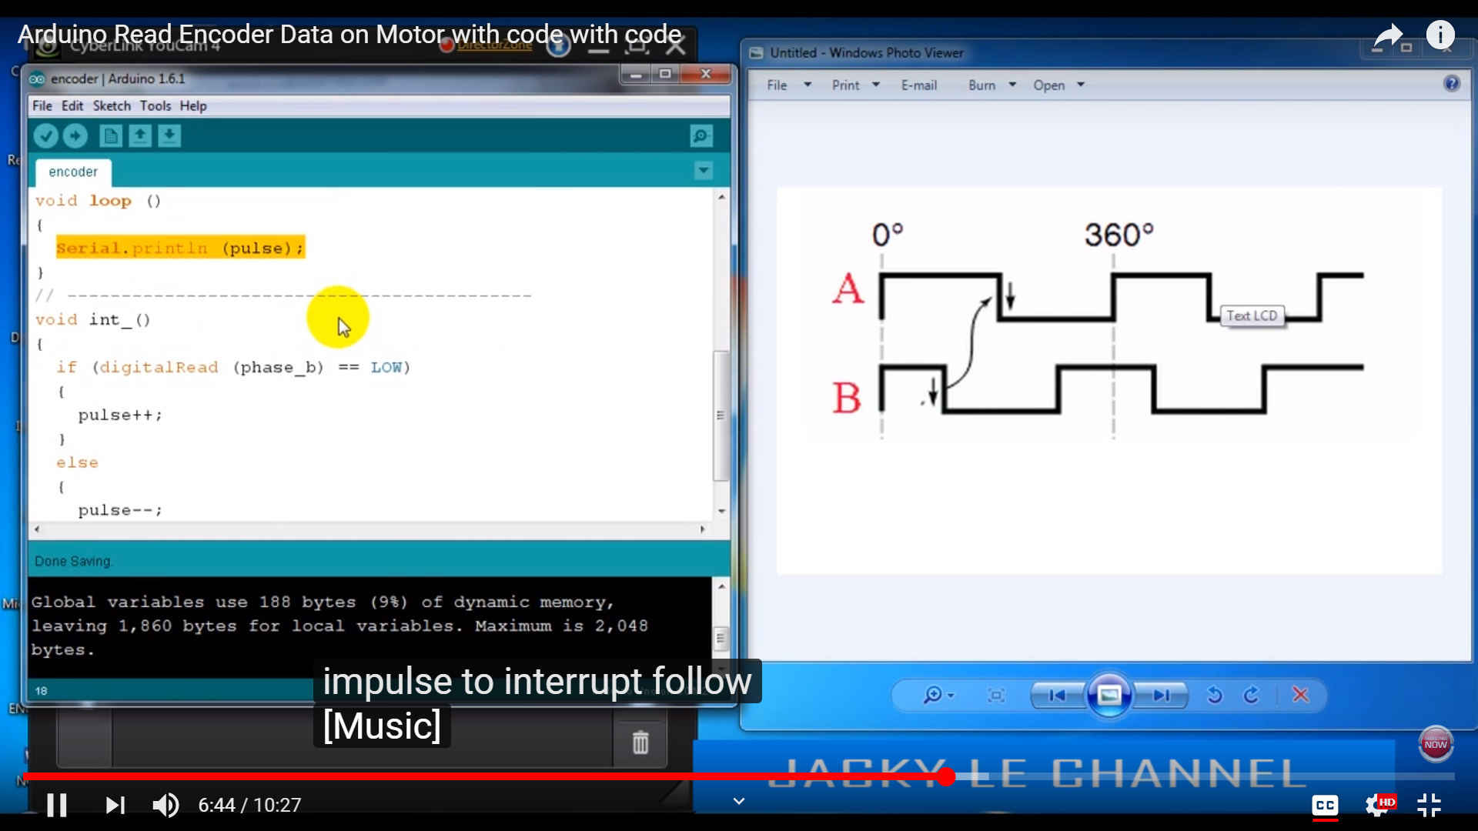

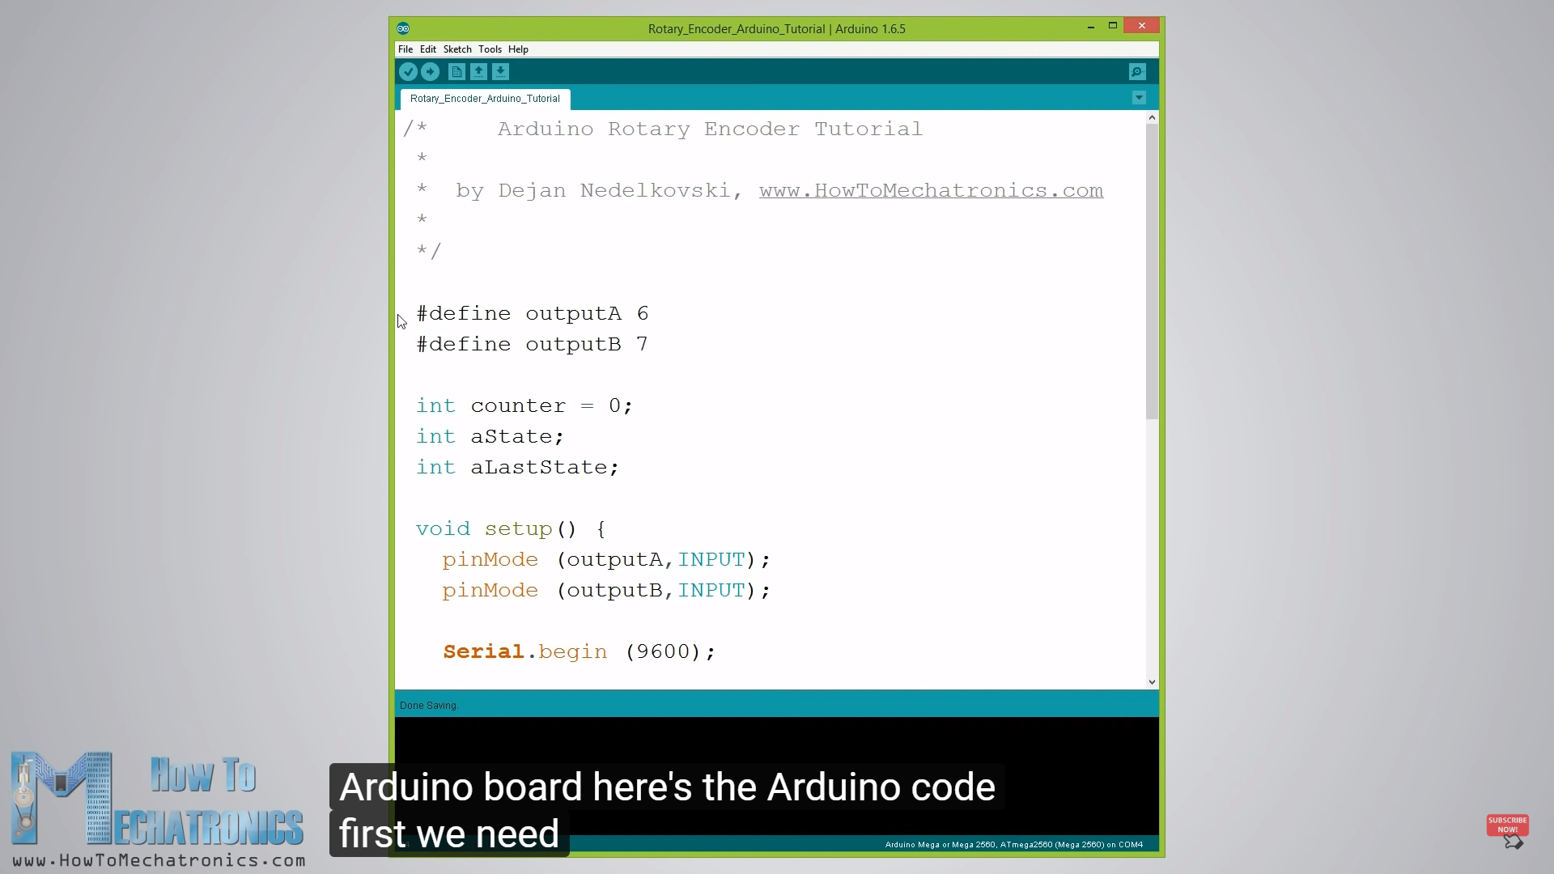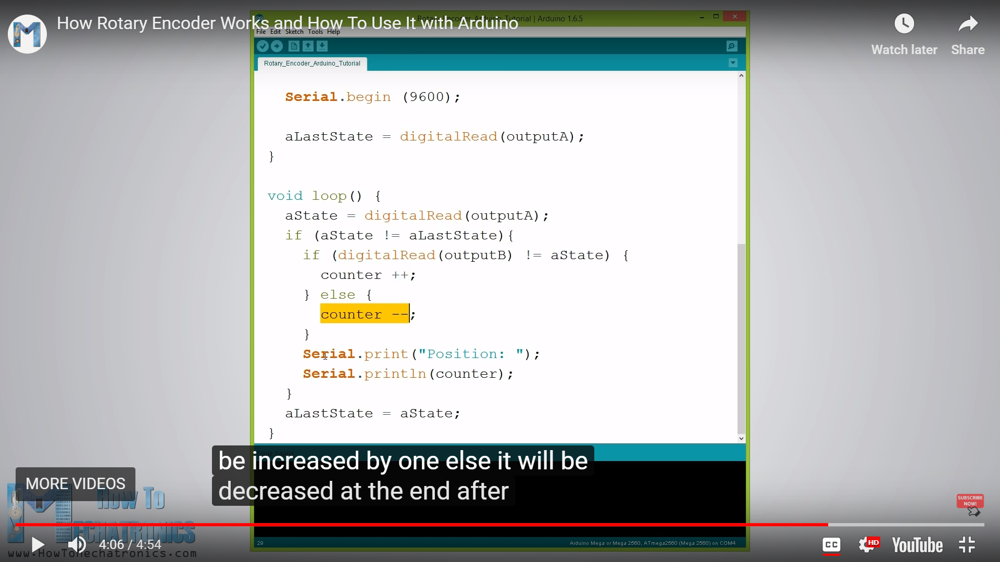

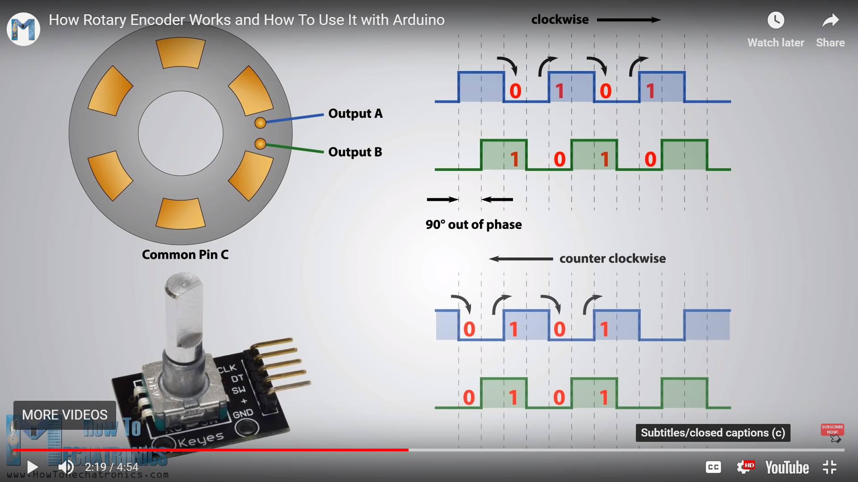

Note: Every time the counter comes in the counter increases and every time the counter goes out it increases.

Why should the counter decrease? It is for counter clockwise rotation. Because the check only comes into application if the last state of signal A is different from present state. Also remember to change the last state to present state.